**Interface**

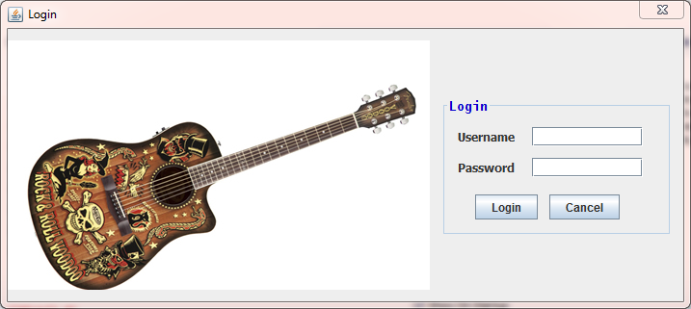

1. Login Form

* Login: To enter the program.
* Cancel: Exit program.

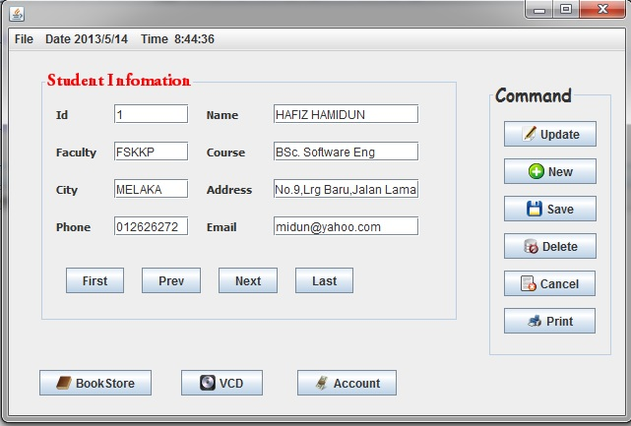

1. Student Form

* First: To show the first record in database.
* Prev: Go to previous record in database.
* Next: To show the next record in database.
* Last: To show the last record of data in database.
* Update: Update the record to database.
* New: To insert the new record.
* Save: To save the new/update record to database.
* Delete: Remove the current record from database.
* Cancel: To reset the field of new data.
* Print: Send the data to printer for printing in hardcopy
* BookStore: To enter Book Store form
* VCD: To enter VCD form
* Account: To enter account form

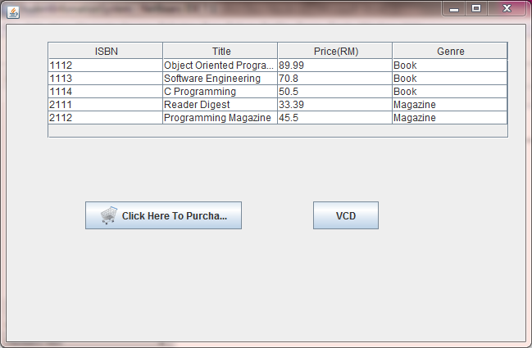

1. Book Store form

* Purchase: Student are required to enter the Customer Name, ContactNo, MemberNo, MemberPoint, how many book to purchase & ISBN to buy the book from BookStore.
* VCD: To open VCD form.

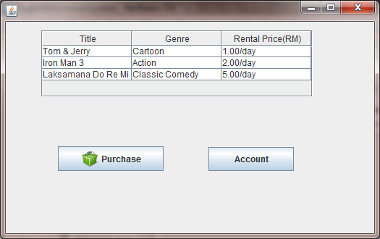

1. VCD form

* Purchase: User must enter Customer Name, Address, Contact no & Rent day to rent the VCD.
* Account: Go to Account form.

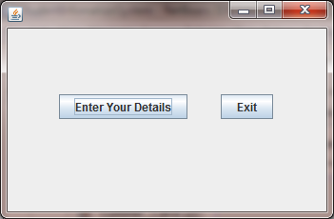

1. Account form

* Enter your details: Sser should enter first name, last name, money in bank, amount to deposit & amount to withdraw to do the payment.
* Exit: Close the Program.